WEB: www.croninsracking.com / EMAIL: croninsracking@eircom.net
PH: 003531-8110092 MOBILE: 087-2569233 FAX: 003531-8110095
UNIT 51, FINGLAS BUSINESS CENTRE, JAMESTOWN ROAD, FINGLAS, D.11.
QUALITY NEW OR USED TO SUIT YOUR BUDGET

LARGE

Wire Stacking baskets blue P.V.C. coated
970mm wide x 460mm high x 690mm deep 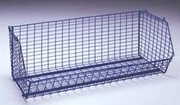

All prices are quoted ex store
Vat not included

PRICE € 65.00 each
LARGE

Dividers for baskets
PRICE € 9.00 each

SMALL

Wire stacking baskets blue P.V.C. coated
970mm wide x 340mm high x 450mm deep

PRICE € 55.00 each
SMALL
Dividers for baskets
PRICE € 8.00 each

4TIER WIRE STACKING BASKETS

Size: 485mm x 485mm x 340mm high

PRICE € 25.00

4 BASKETS FOR € 100.00

ROUND DUMP BASKET

@ € 35.00 each

